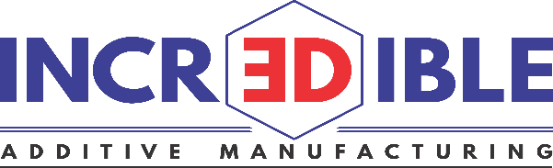

Training Content
MODULE 1 – Introduction to Laser Processing and Metal 3D Printing
How laser works? Types of lasers used in AM process and its effect on 3D printing. It explains what metal 3D printing is, its types, advantages, limitations

MODULE 2 – Raw Material for Metal 3D Printing
It explains powder morphology, powder testing, effect of change of powder quality on part quality, materials available for 3D printing

MODULE 3 – Design for Additive Manufacturing (DFAM)
It explains shift in design strategy and ease of achieving complex designs, limitations must be considered while designing a part, when to choose additive manufacturing, software used in AM

MODULE 4 – Metal 3D Printing Process
Describes 3D printing process from the very beginning to dispatch (On-Field training as well)

MODULE 5 – Metal 3D Printing Applications
Describes various applications in Automobile, tool, Aerospace, Medical, Interior design industries, why and how to adopt 3D Metal Printing

MODULE 6 – Future Development in Metal 3D Printing
Describes research going on in the field and its implications on additive
manufacturing industry in coming years

Schedule of the program

Time | Module/Event
10:30 am | Reporting
11:00-11.15 am | Introduction to Metal 3D printing and laser processing
11:15-11:30 am | Introduction to Raw Material in 3D printing
11.30:12:00pm | Design for Additive Manufacturing
12:00-12:30 pm | Raw material - on field Demo
1:00-2:00 pm | Lunch
2:00-2:15 pm | 3D Metal Printing Process
2:15-2:45pm | Metal 3D Printing Applications
2:45-3:00 pm | Future of metal 3D printing
3:00-3:15 pm | Tea/coffee
3:15-4:00 pm | 3D Printing shop floor demo
4:00-4:30 pm | Career Opportunities in Additive Manufacturing

